**Demo Testing**

**Batch File Execution**

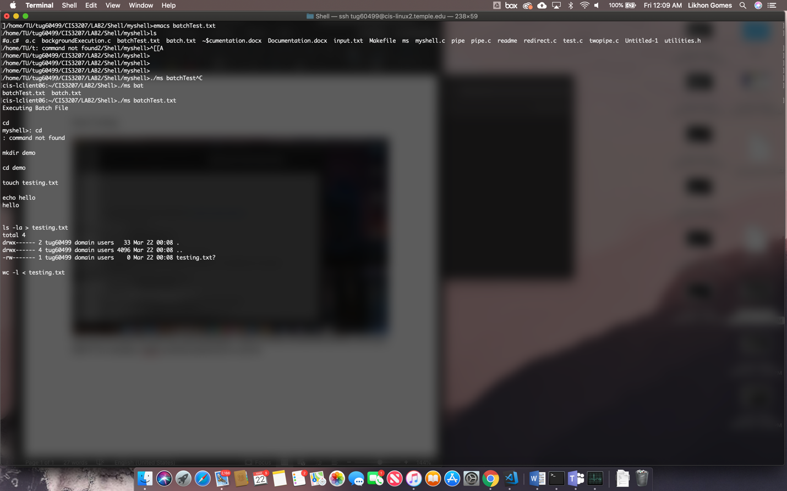

Executed the batch file with the commands given. It worked almost perfectly, only bug was when I did mkdir demo it added a question mark in the name of the directory. So the name of the directory was “demo?”

**Executing commands one by one**

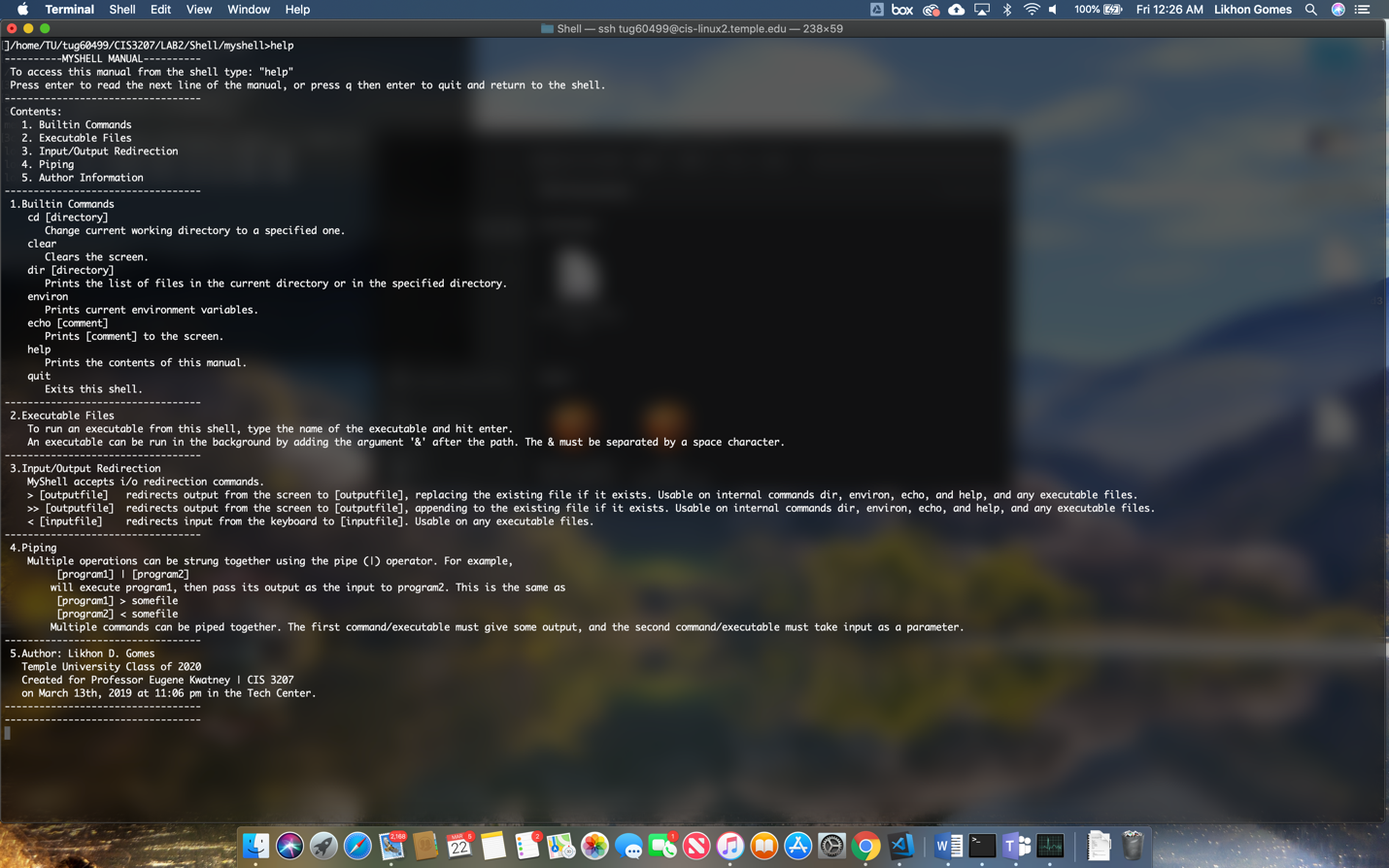

Did the help command in my shell and this is what I got.

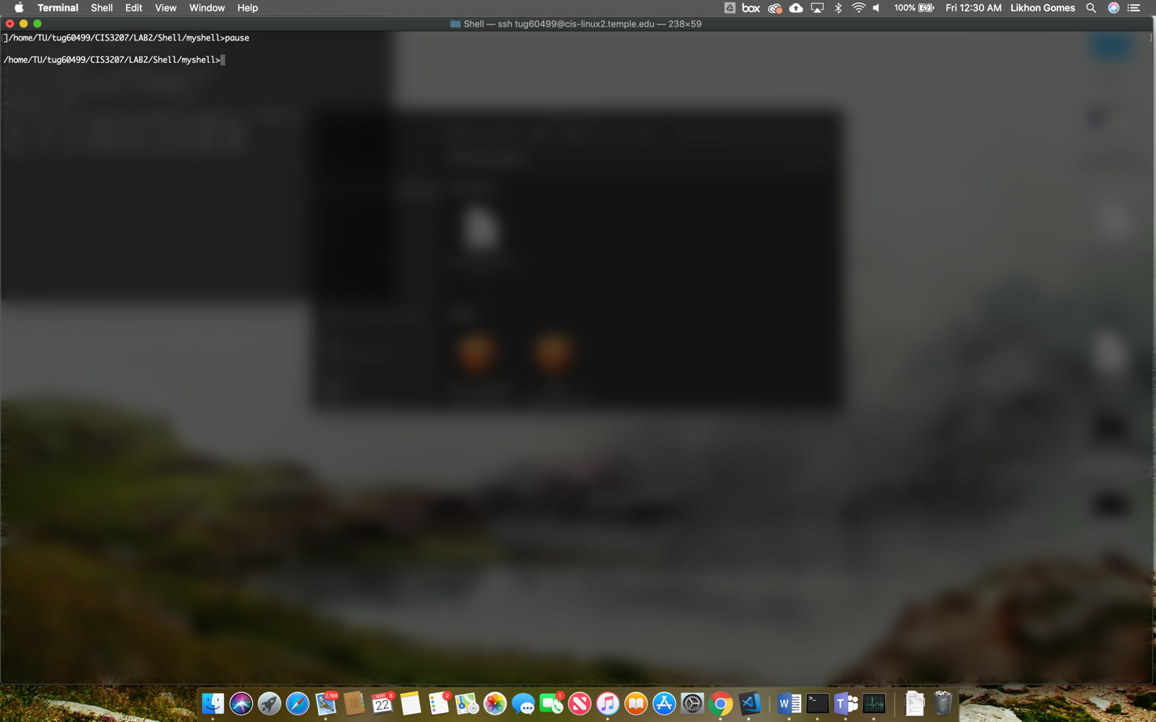

The screenshot above was taken when I used “pause” command. It paused my shell for a while and then I pressed the return key and it resumed its operation.

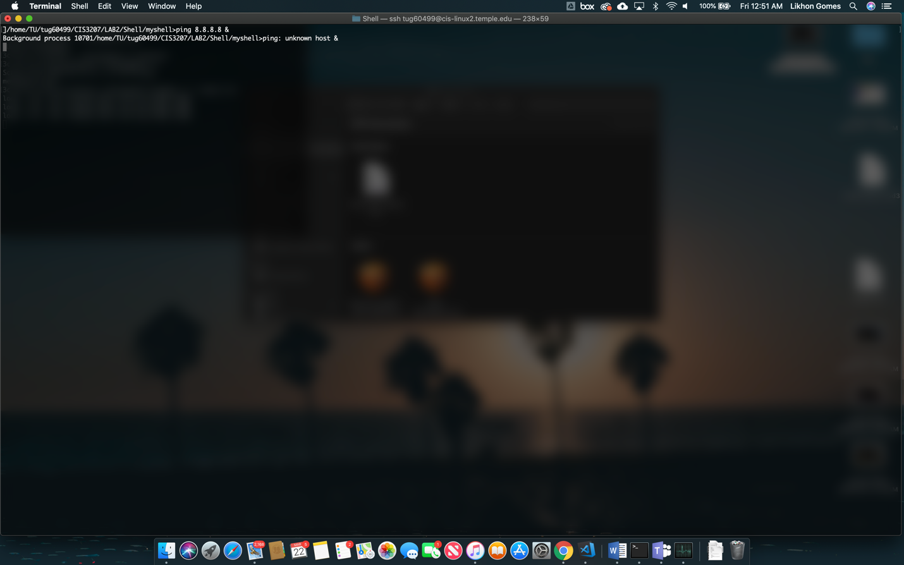

Ping 8.8.8.8 & didn’t work because for some reason my parser was not ignoring & from the shell.

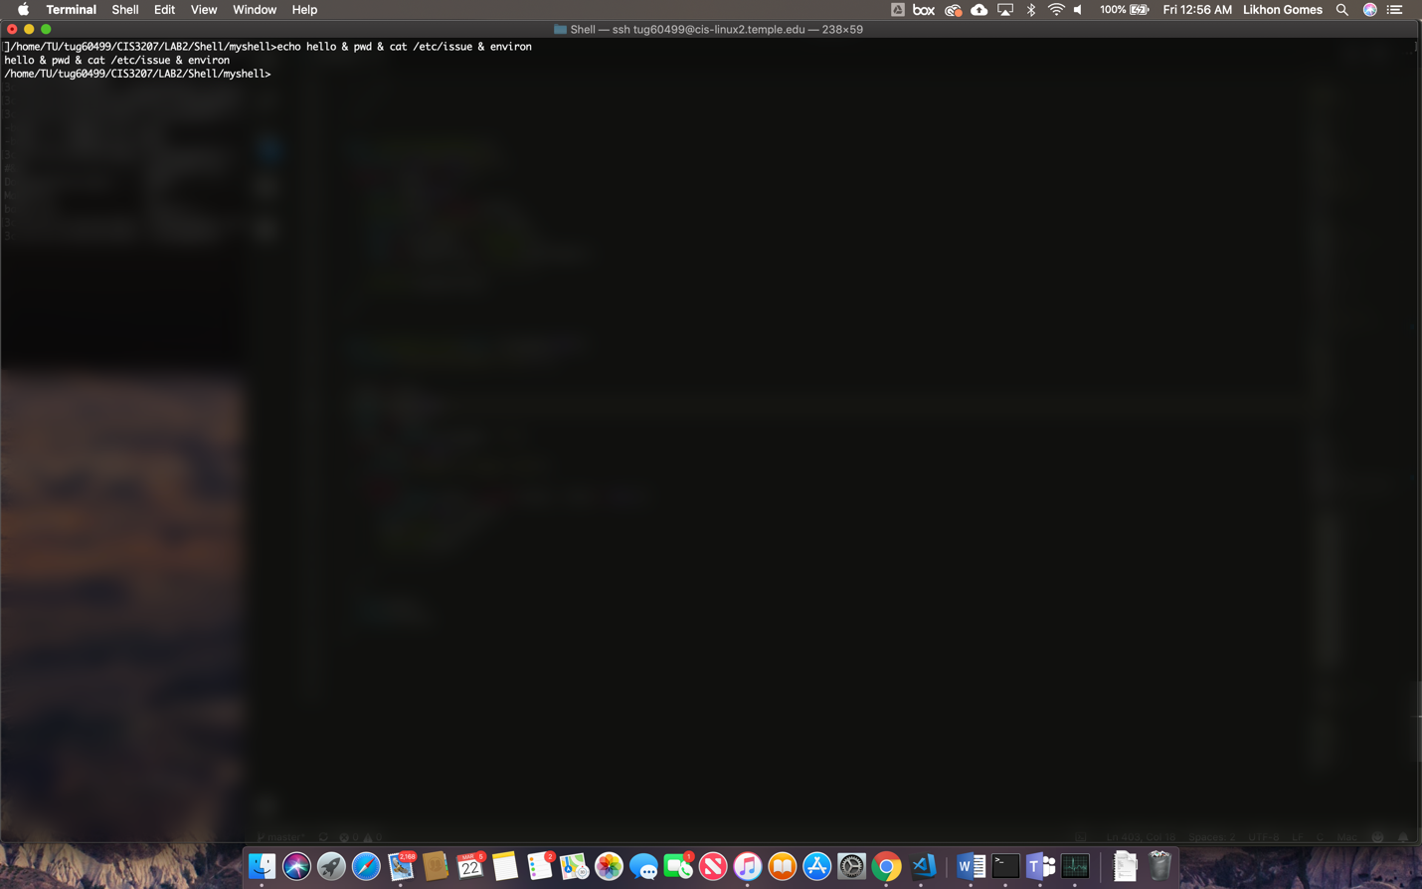

Tried the “echo hello & pwd & cat /etc/issue & environ” command to start parallel execution but once again the parser got it wrong.

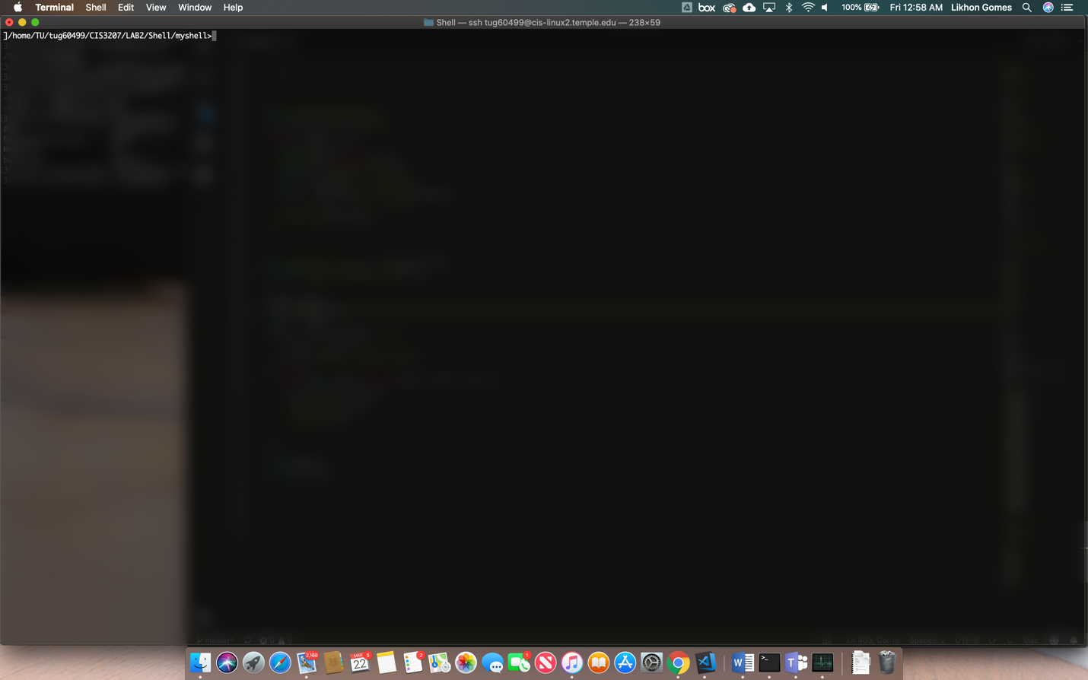

Here’s my screenshot after I used “clr”.



Here’s my screenshot after I used the command quit to quit my shell. Exit works as well.

**Testing the parser**

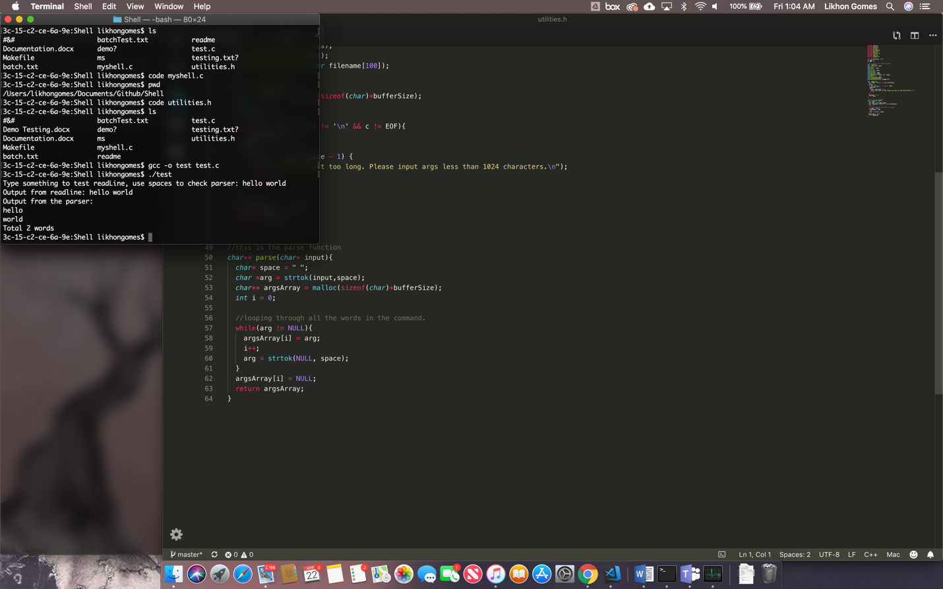

Here’s how I tested my parser. I wrote a special test code to test it. In the prompt I wrote hello world and the parser parsed them as individual words.